**********************************************************************************
KUBEBYTES INTERNAL EXAMINATION 2026 ON AWS AND DEVOPS TOOLS Day - 03
**********************************************************************************
Deployed a web application and managed RELEASE and SNAPSHOT versions using Sonatype Nexus Repository.
✅ Step 1: Create an EC2 Instance (AWS)
- Login to AWS Console
- Go to EC2 Dashboard
- Click Launch Instance
- Configure:
  - Name: My-Server
  - OS: Ubuntu (Recommended)
  - Instance type: t2.micro (Free tier)
- Create/Select Key Pair (Download .pem file)
- Allow ports:
  - 22 (SSH)
  - 8080 (Tomcat)
  - 8081 (Nexus)
- Click Launch Instance

✅ Step 2: Connect EC2 using MobaXterm
- Open MobaXterm
- Click Session → SSH
- Enter:
  - Remote host: EC2 Public IP
  - Username: ubuntu
- Go to Advanced SSH settings
  - Select your .pem key
- Click OK → Connected ✅

✅ Step 3: Clone Web Application
sudo apt update
sudo apt install git -y
git clone <YOUR_GIT_REPO_URL>
cd <project-folder>

✅ Step 4: Install Maven
sudo apt install maven -y
Check version:
mvn -v

✅ Step 5: Build the Project
mvn clean install
👉 This will:
- Download dependencies into .m2 directory
- Generate .war file inside target/

✅ Step 6: Deploy to Sonatype Nexus (Docker Setup)

1️⃣ Install Docker
sudo apt install docker.io -y
sudo systemctl start docker
sudo systemctl enable docker

2️⃣ Create Nexus Data Directory
mkdir nexus-data
sudo chown -R 200:200 nexus-data

3️⃣ Pull Nexus Image
docker pull sonatype/nexus3

4️⃣ Run Nexus Container
docker run -d -p 8081:8081 --name nexus \
-v ~/nexus-data:/nexus-data sonatype/nexus3

5️⃣ Check Container Status
docker ps

6️⃣ Access Nexus
Open browser:
http://<EC2_PUBLIC_IP>:8081
👉 Default login:
- Username: admin
- Password: inside container:
docker exec -it nexus cat /nexus-data/admin.password

✅ Step 7: Create Repository in Nexus
- Go to Settings → Repositories
- Create:
  - maven-releases
  - maven-snapshots

✅ Step 8: Edit pom.xml
Add:
<distributionManagement>
<repository>
<id>nexus-releases</id>
<url>http://<EC2_IP>:8081/repository/maven-releases/</url>
</repository>
<snapshotRepository>
<id>nexus-snapshots</id>
<url>http://<EC2_IP>:8081/repository/maven-snapshots/</url>
</snapshotRepository>
</distributionManagement>

✅ Step 9: Edit settings.xml
Location:
~/.m2/settings.xml
Add:
<servers>
<server>
<id>nexus-releases</id>
<username>admin</username>
<password>admin_password</password>
</server>
<server>
<id>nexus-snapshots</id>
<username>admin</username>
<password>admin_password</password>
</server>
</servers>

✅ Step 10: Deploy to Nexus
mvn clean deploy
👉 Artifact will be uploaded to Nexus

✅ Step 11: Version Update
- Snapshot version
<version>1.0-SNAPSHOT</version>
- Release version
<version>1.0</version>

✅ Step 12: Install Apache Tomcat
sudo apt install tomcat9 -y
Start Tomcat:
sudo systemctl start tomcat9
sudo systemctl enable tomcat9

✅ Step 13: Deploy WAR File to Tomcat
Copy WAR file:
sudo cp target/*.war /var/lib/tomcat9/webapps/
Restart Tomcat:
sudo systemctl restart tomcat9

✅ Step 14: Access Application
Open browser:
http://<EC2_PUBLIC_IP>:8080/<war-file-name>

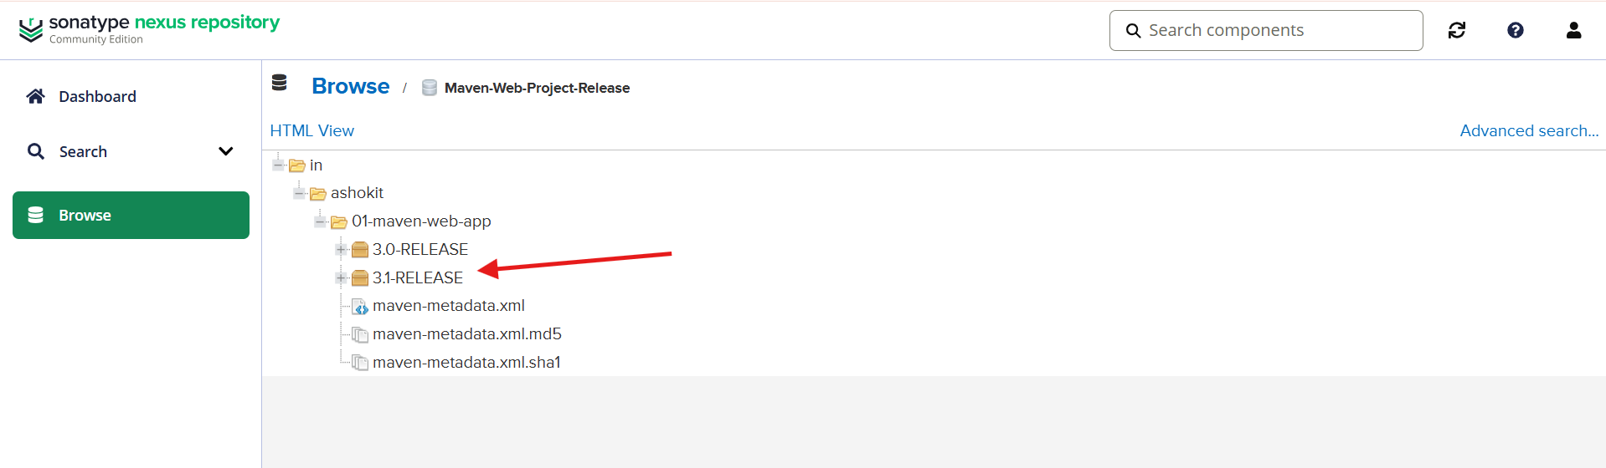

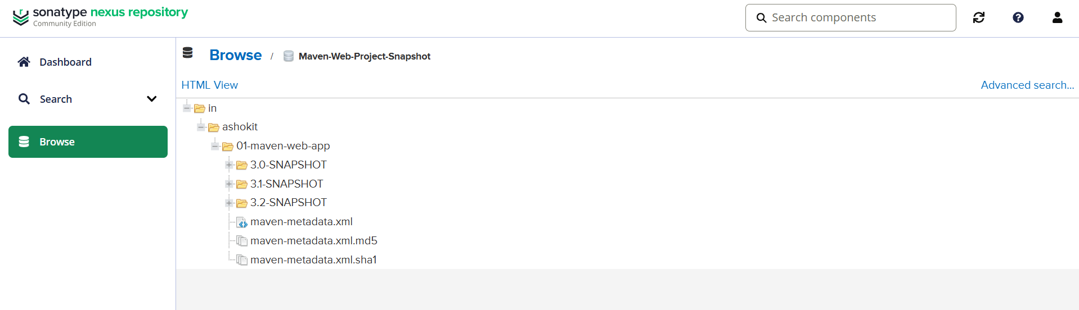
Web-app
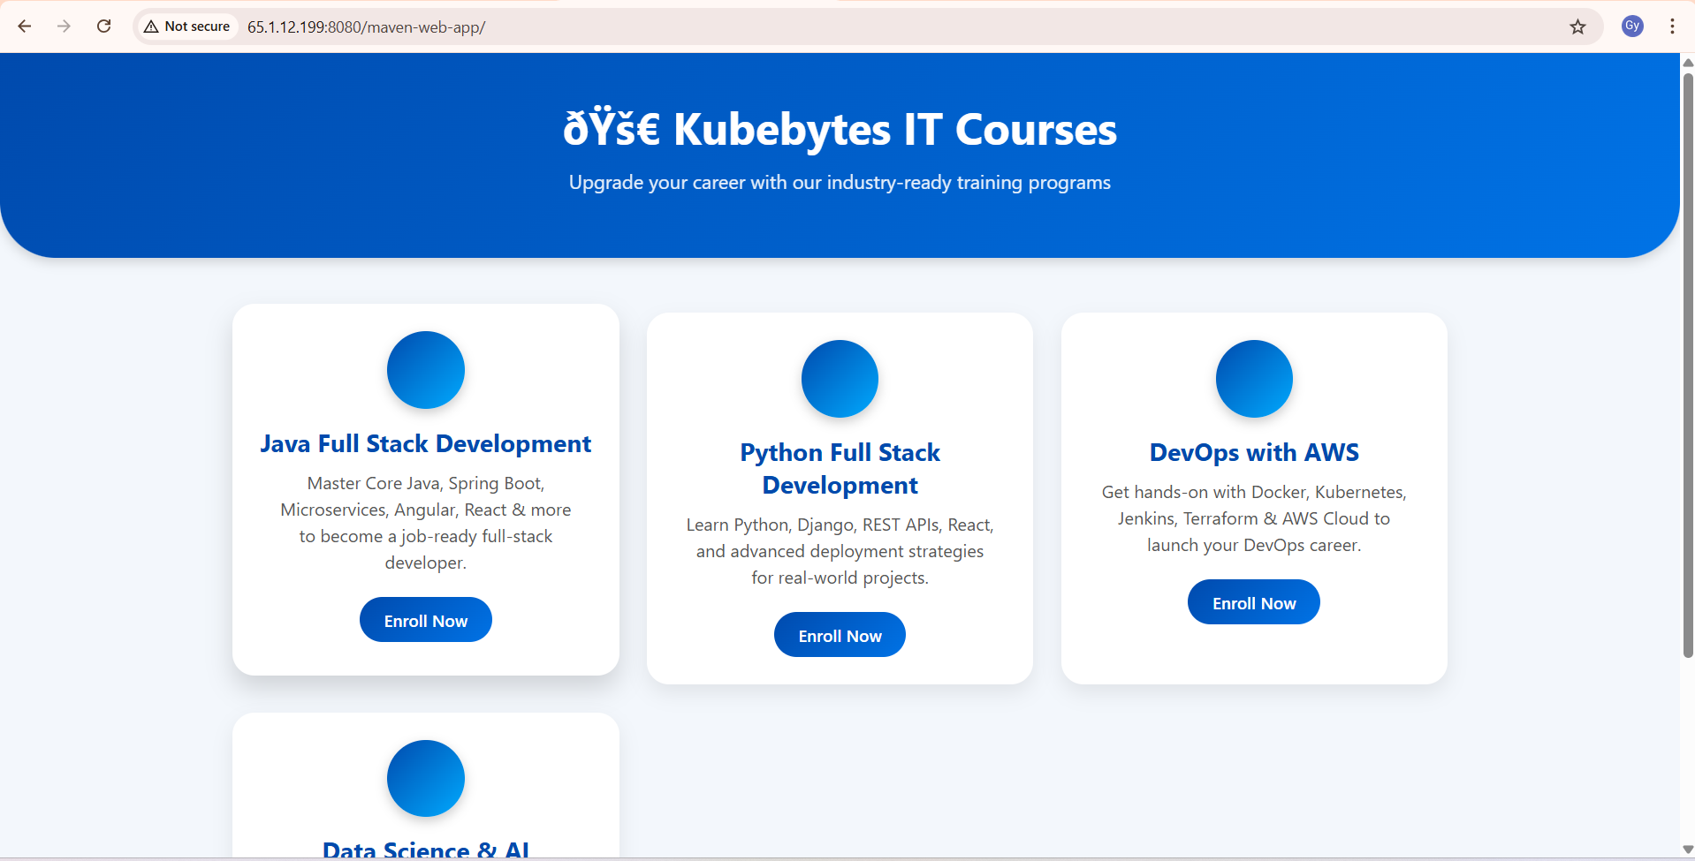

Developed and deployed a Java-based project integrated with a MySQL database.

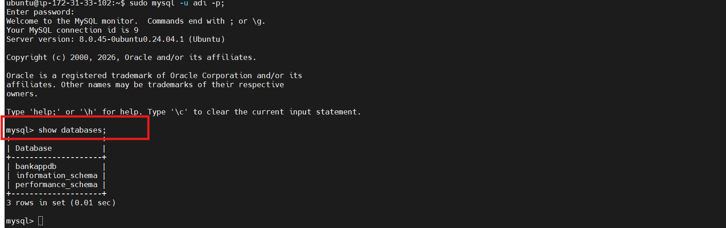
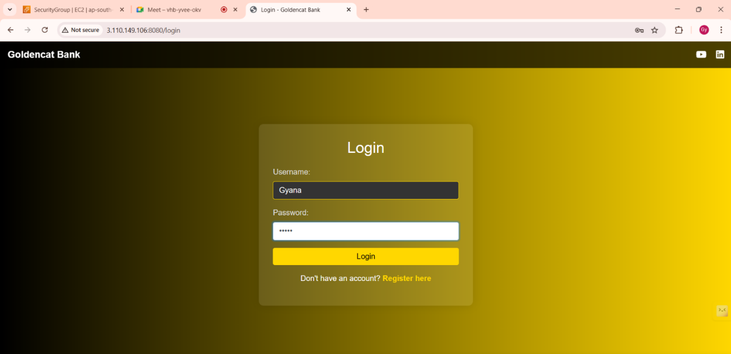
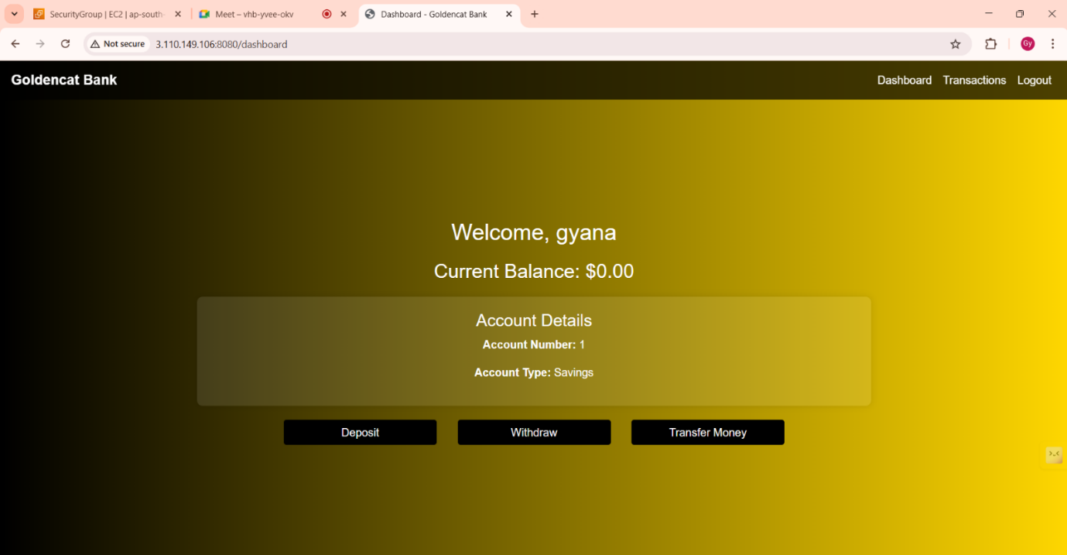

Stored release and snapshot versions of a standalone project in Sonatype Nexus Repository.
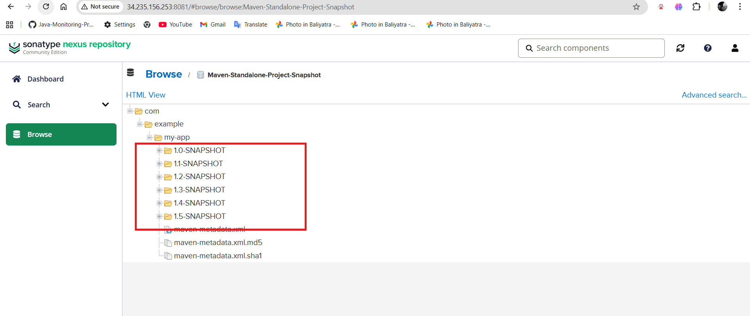
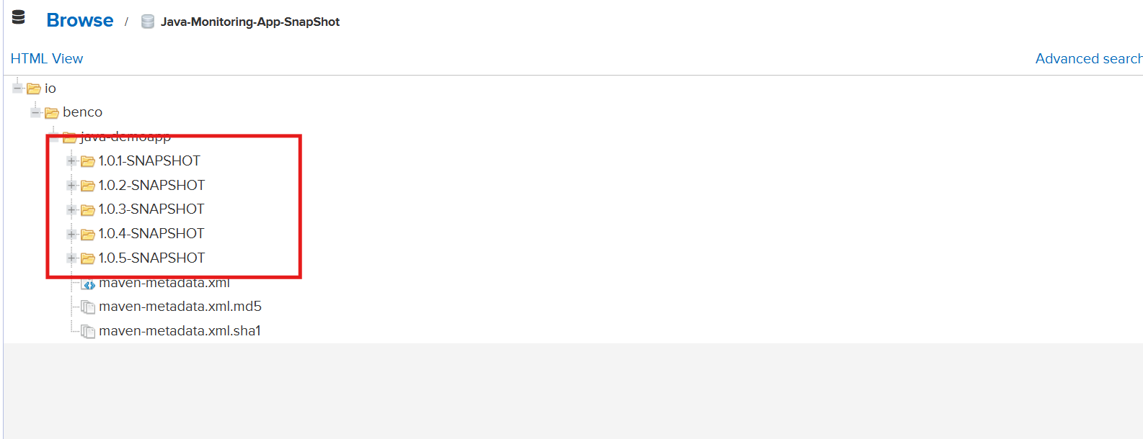
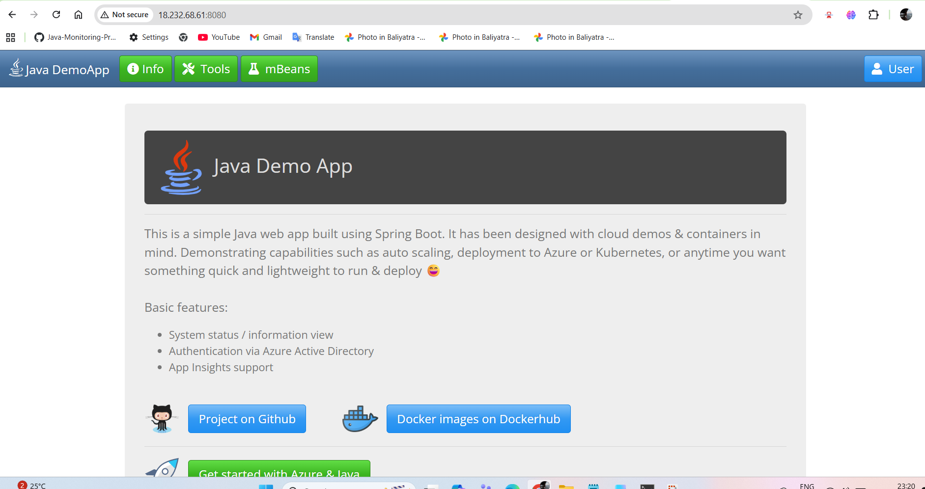
Implemented an end-to-end DevSecOps workflow using Maven, Trivy, Nexus, and Apache Tomcat.
✅ Step 1: Create EC2 Instance
✅ Step 2: Connect EC2 via MobaXterm
✅ Step 3: Clone Project & Build
✅ Step 4: Install & Use Trivy (Security Scan)
✅ Step 5: Fix Vulnerabilities
👉 If HIGH/CRITICAL issues found:
- Inform developer
- Fix dependencies or code
- Re-run scan
✅ Step 6: Maven Local Repository
- .m2 folder is created automatically
- Location:
~/.m2
👉 Stores dependencies & settings.xml
✅ Step 7: Deploy to Nexus Repository (Docker Setup)
1️⃣ Install Docker
2️⃣ Create Nexus Data Directory
3️⃣ Pull Nexus Image
4️⃣ Run Nexus Container
5️⃣ Check Container
6️⃣ Access Nexus
http://<EC2_PUBLIC_IP>:8081
7️⃣ Get Admin Password
✅ Step 8: Create Repository in Nexus
- maven-releases
- maven-snapshots
✅ Step 9: Edit pom.xml
✅ Step 10: Edit settings.xml
✅ Step 11: Version Update
✅ Step 12: Install Apache Tomcat
✅ Step 13: Deploy WAR File
✅ Step 14: Access Application

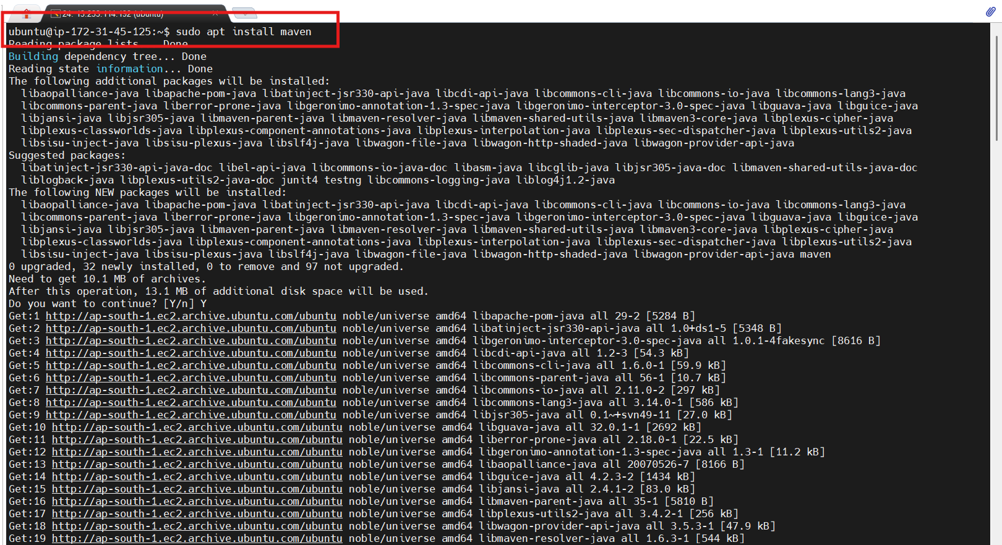
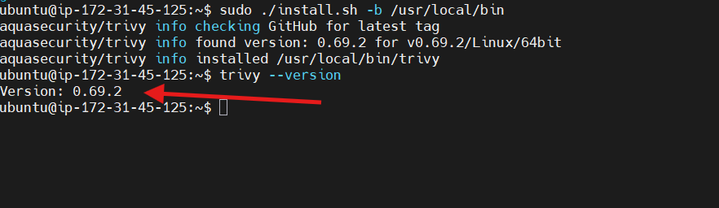
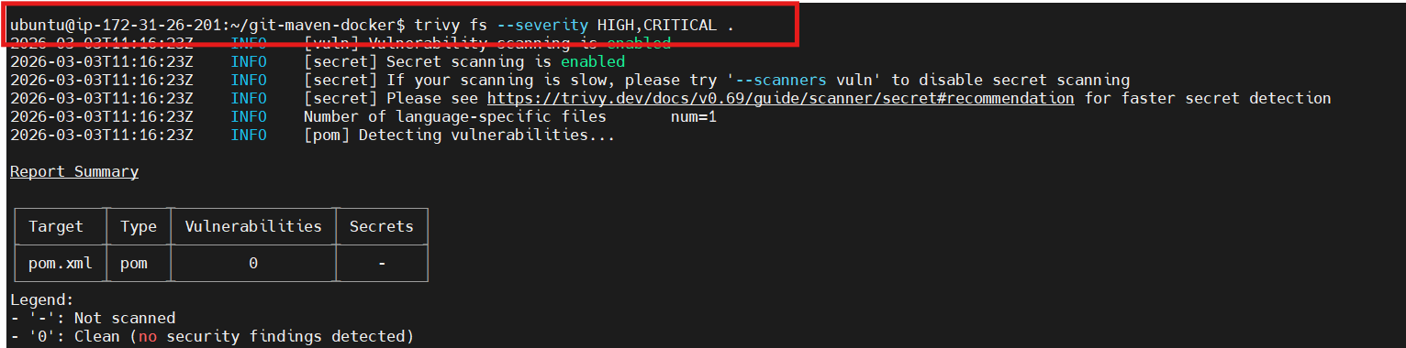
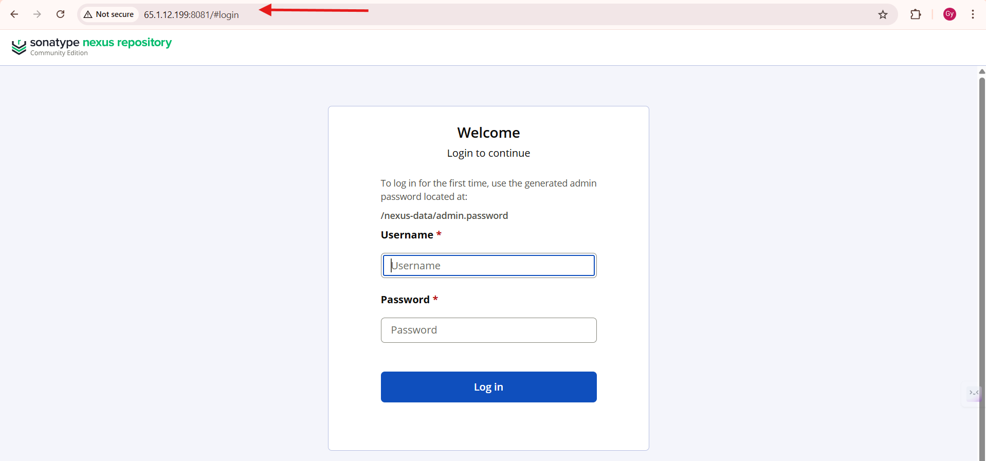
Designed a DevSecOps CI/CD pipeline using Maven, Trivy, Nexus, SonarQube, and Tomcat.

Launched a monolithic web application on an AWS EC2 instance using user data scripts.
✅ Step 1: Open EC2 Console
✅ Step 2: Configure Instance
✅ Step 3: Key Pair & Network Settings
✅ Step 4: Open Advanced Details
✅ Step 5: Add User Data Script
✅ Step 6: Launch Instance
✅ Step 7: Access Website
- Copy Public IP Address
- Open browser
- Enter:
http://<EC2_PUBLIC_IP>

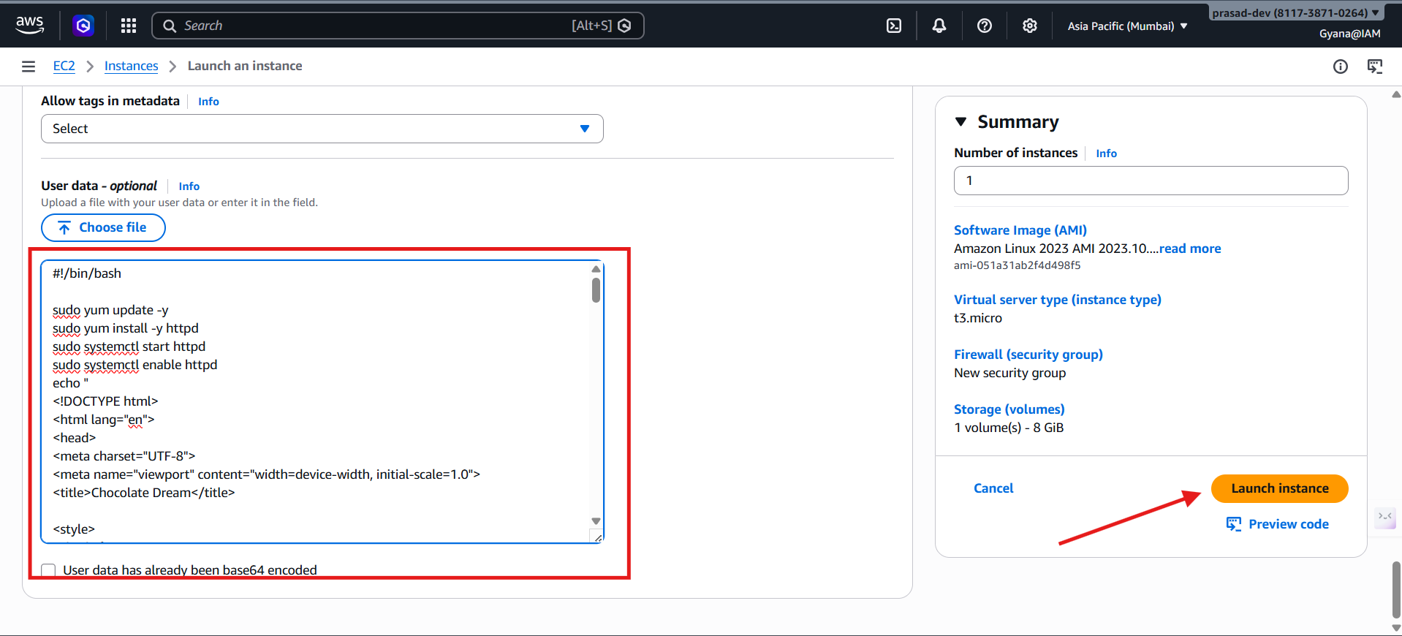
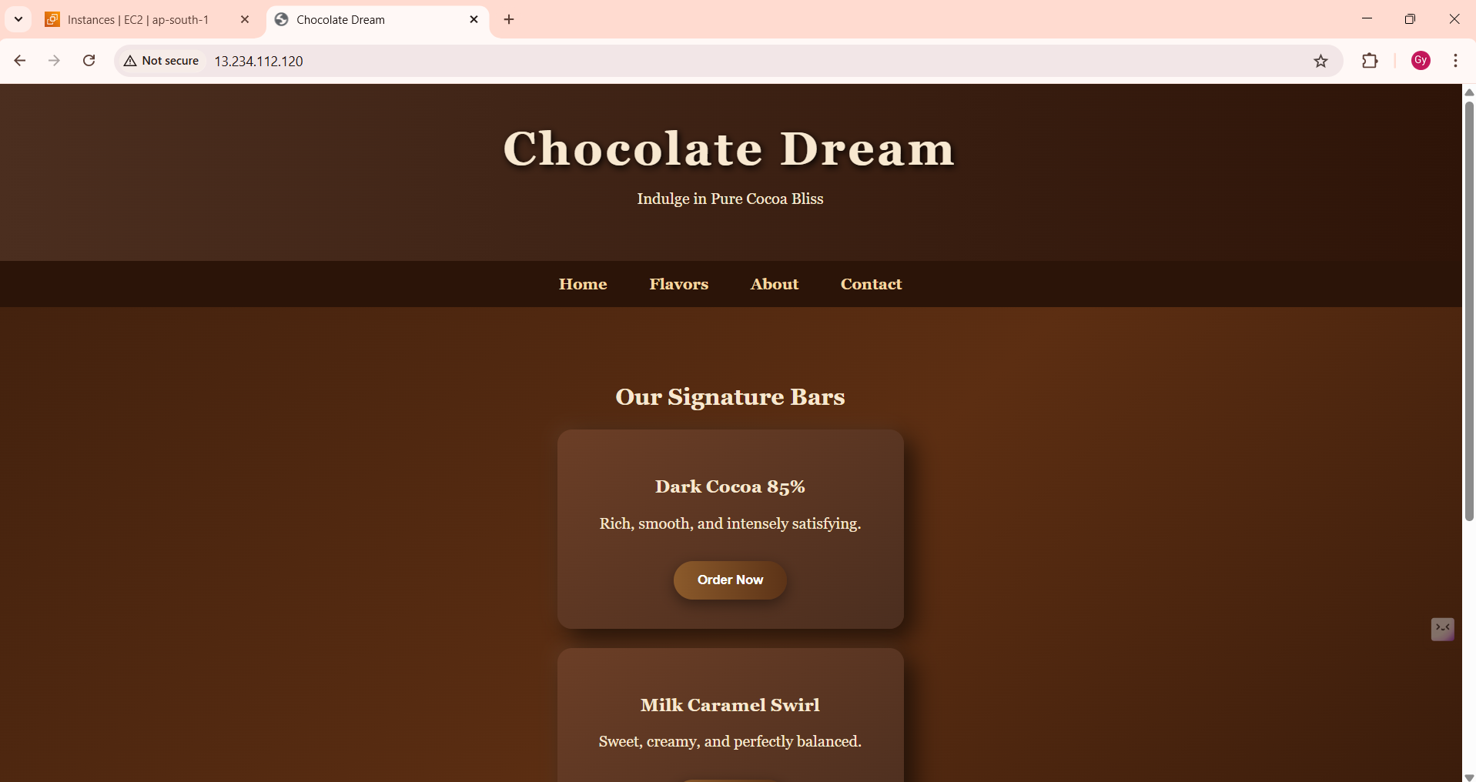

Allocated and configured an Elastic IP address for an EC2 instance.
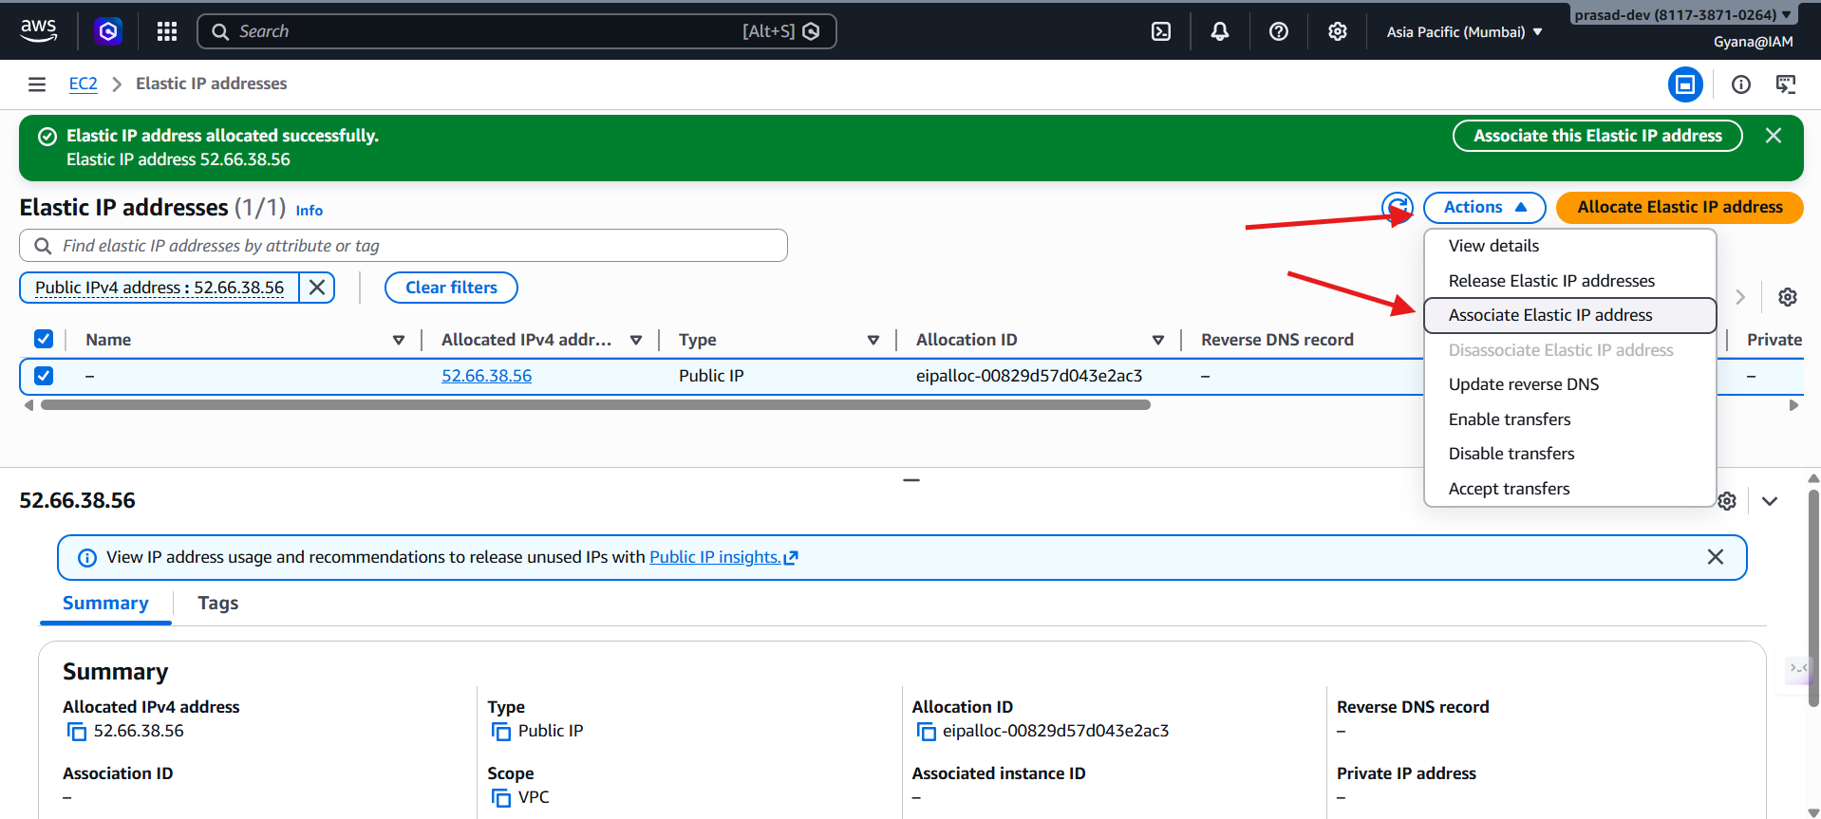
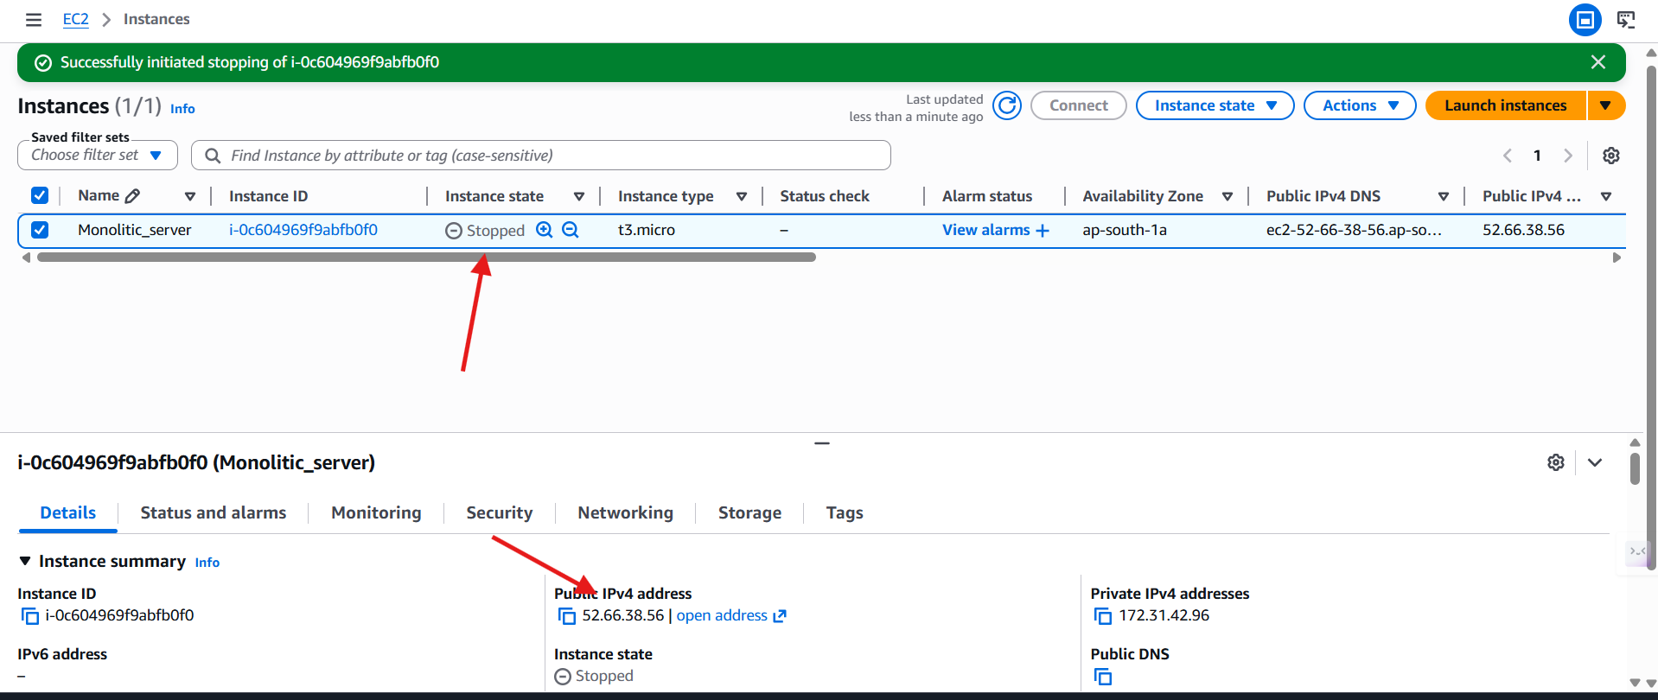
Built and automated a complete DevSecOps pipeline integrating Maven, Trivy, Nexus, SonarQube, and Tomcat.
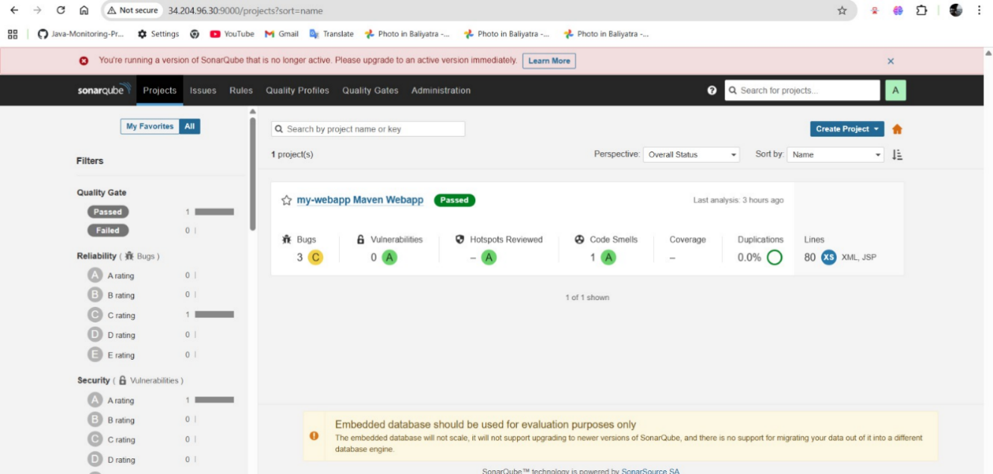

Practiced version control and collaboration using GitHub.
✅ Step 1: Developer-1 Creates Repository
i) Create a new repository in GitHub
ii) Create a file and add content:
echo "Hello World" > f1.txt
iii) Add, commit, and push:
git add f1.txt
git commit -m "Initial commit"
git push origin main

✅ Step 2: Developer-2 Clones Repository
i) Clone repository:
git clone <repo_url>
cd <repo_name>
ii) Modify file:
nano f1.txt
👉 Change content:
Hello from Developer-2
iii) Commit and push:
git add f1.txt
git commit -m "Updated by Developer-2"
git push origin main

✅ Step 3: Developer-1 Makes Changes
👉 Developer-1 still has old file
i) Edit file:
nano f1.txt
👉 Change content:
Hello from Developer-1
ii) Commit:
git add f1.txt
git commit -m "Updated by Developer-1"

✅ Step 4: Pull Changes (Conflict Happens)
git pull origin main
👉 Git shows merge conflict ❌

✅ Step 5: Resolve Conflict
Open file:
nano f1.txt
👉 You will see:
<<<<<<< HEAD
Hello from Developer-1
=======
Hello from Developer-2
>>>>>>> main
👉 Fix manually (choose or combine):
Hello from Developer-1 and Developer-2
👉 Remove:
- <<<<<<<
- =======
- >>>>>>>

✅ Step 6: Commit & Push Final Code
git add f1.txt
git commit -m "Resolved merge conflict"
git push origin main

Hosted a web application using Jenkins automation and deployed it on Apache Tomcat
